Water Resources Integrated Modeling System Development Plan

**Draft Report**

**July 2010**

**Prepared under the supervision of**

Sanjaya Seneviratne

Senior Engineer

Modeling Support Branch, Bay-Delta Office

**Prepared by**

Kevin Kao

Engineer

Modeling Support Branch, Bay-Delta Office

Table of Contents

Table of Figures 5

Executive Summary 6

Introduction 6

Water Resources Integrated Modeling System (WRIMS) 6

Features of WRIMS version 1.3 6

WRESL Language Parser and Compiler 6

Data Post-processor 7

Grphical User Interface 7

Proposed Improvements 7

Simultaneous Multi-Period Optimization 7

Automated Self-checking Tests 7

Incremental Parser for WRESL Language 8

List Types Incremental Compilation 8

Modular Syntax for WRESL Language 8

modular Design for Controller GUI 9

Estimated Benefit of the proposed Improvements 9

Simultaneous Multi-Period Optimization 9

Development Schedule 9

Phase 1 (08/2010 – 12/2010) 9

Task 1 9

Task 2 10

Phase 2 (12/2010 – 06/2011) 10

Phase 2 (06/2011 – 12/2011) 10

Appendix: Additional resources 11

Additional Resources 11

References 11

Author-Date System 11

Books 11

Parts of a Book 12

Periodicals 12

Reports 12

Theses and Dissertations 12

Papers Presented at Meetings 12

Online Sources 12

CD-ROMs 13

Notes System 13

Books 13

Parts of a Books 13

Periodicals 13

Reports 13

Theses and Dissertations 14

Papers Presented at Meetings 14

Online Sources 14

CD-ROMs 14

# Table of Figures

Figure 1. Iterative solution for multi-period optimization in WRIMS version 1.3 and 2. 6

Figure 2. Simultaneous solution for multi-period optimization in future generation of WRIMS. 6

Figure 3. Flowchart for next-generation WRIMS. Mathematical Programming System (MPS) is a de facto standard file format for linear and integer programming. 6

Figure 4. A configuration file containing all required information to run a study can be generated either from the controller GUI or user’s own script. This provides flexible scripting and batch processing without invoking the controller GUI. 7

# Executive Summary

This report template provides style and formatting suggestions to help researchers working on CTRE project reports. To use this template, make a copy of the file, delete the example text, and begin composing your report, referring to the examples and tips in the original document if necessary.

# Introduction

Understanding the following two steps can help you use Microsoft Word to create an uncluttered and consistently formatted report.

## Water Resources Integrated Modeling System (WRIMS)

WRIMS is the standard planning tool for State Water Project and Central Valley Project in Department of Water Resources. Upgrading the FORTRAN compiler to be compatible with Windows 7 operating system is critical for the modernization of WRIMS.

WRIMS (a.k.a. CALSIM) which is used as a planning tool to simulate the State Water Project and Central Valley Project.

WRIMS 1 (a.k.a. CALSIM II) can generate individual computer executables for each planning scenario by calling Lahey FORTRAN compiler version 4.5. However, this version of Lahey FORTRAN is no longer supported by the vendor and is not compatible with Windows 7 operating system. Purchasing a new version of Lahey FORTRAN compiler can speed up the migration of WRIMS from Windows XP to Windows 7 operating system.

# Features of WRIMS version 1.3

## WRESL Language Parser and Compiler

WRESL language is parsed using a Java based compiler compiler named Java CC to compose FORTRAN codes containing rules to form linear programming constraint matrices. The generated FORTRAN codes are then compiled and linked with DSS input/output modules to make an executable file. Lahey FORTRAN compiler is used to perform the compilation.

## Data Post-processor

setsetsetset

## Grphical User Interface

Setsetasetae

# Proposed Improvements

## Simultaneous Multi-Period Optimization

Multi-period optimization is useful for water allocation planning with some degree of foresight in hydrology input data. By assembling multi-period constraints and decision variables into “single set” of LP constraints and objective functions, multi-period optimization can be solved simultaneously instead of iteratively.

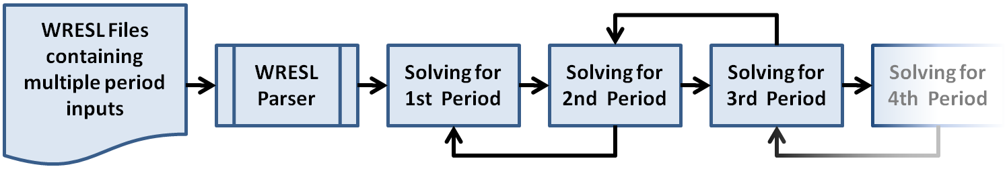

Figure . Iterative solution for multi-period optimization in WRIMS version 1.3 and 2.

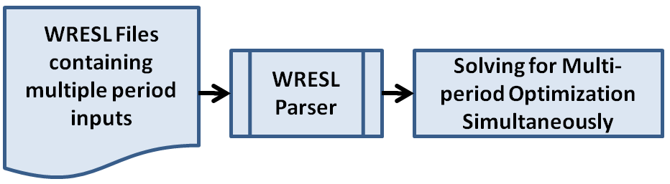

Figure . Simultaneous solution for multi-period optimization in future generation of WRIMS.

## Automated Self-checking Tests

Debugging for WRIMS can be improved if the input data transferred to LP solvers is transparent and easily accessible to both modelers and developers. The input data includes LP variables, constraint matrices, and objective functions. and data is difficult and time-consuming because the data transfer from WRIMS to XA solver is not transparent. To port XA solver, WRIMS either writes FORTRAN codes (in version 1.3), or calls XA’s JAVA interface function directly (in version 2). The de facto standard file format for linear and integer programming called “Mathematical Programming System”, or MPS, is not generated as the check-point between WRIMS and XA solver.

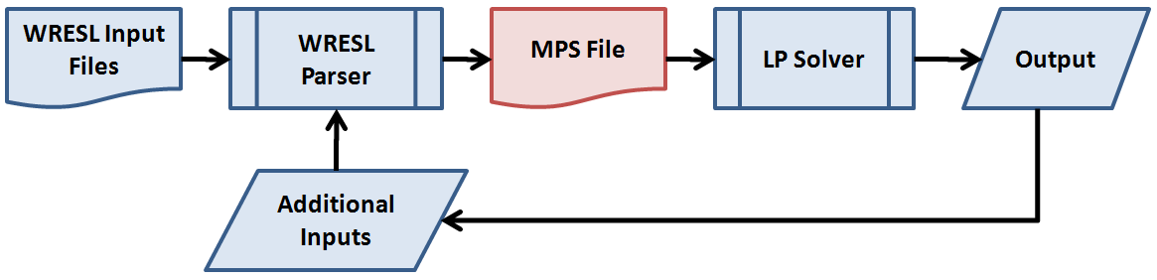

Figure . Flowchart for next-generation WRIMS. Mathematical Programming System (MPS) is a de facto standard file format for linear and integer programming.

## Incremental Parser for WRESL Language

All

### List Types Incremental Compilation

To list items within a sentence, give one, two, and three. To emphasize the number of items, give (1) one, (2) two, and (3) three.

## Modular Syntax for WRESL Language

All CTRE reports should have a technical report documentation page (first page of this template), with identifying information and an abstract. The technical report documentation page follows the front cover for the convenience of the sponsor and readers. The abstract will also be used to communicate the project results on the web.

## modular Design for Controller GUI

A configuration file containing all required information to run a study can be generated either from the controller GUI or user’s own script. This provides flexible scripting and batch processing without invoking the controller GUI.

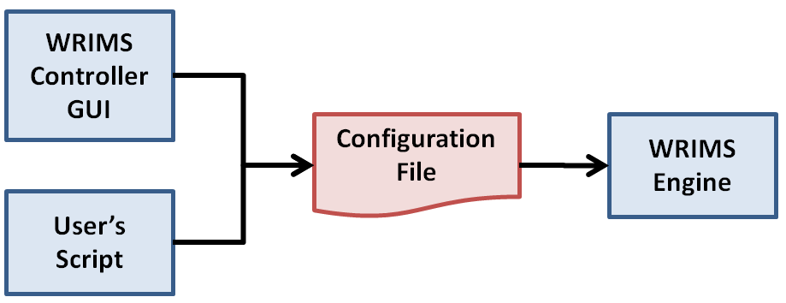

Figure . A configuration file containing all required information to run a study can be generated either from the controller GUI or user’s own script. This provides flexible scripting and batch processing without invoking the controller GUI.

# Estimated Benefit of the proposed Improvements

## Simultaneous Multi-Period Optimization

Multi-period optimization is useful for water allocation planning with some degree of foresight in hydrology input data. By assembling multi-period constraints and decision variables into “single set” of LP constraints and objective functions, multi-period optimization can be solved simultaneously instead of iteratively.

# Development Schedule

## Phase 1 (08/2010 – 12/2010)

### Task 1

All dev

### Task 2

All dev

## Phase 2 (12/2010 – 06/2011)

All dev

## Phase 2 (06/2011 – 12/2011)

All dev

Table 1. Road length by pavement serviceability

|  |  |  |  |
| --- | --- | --- | --- |
| **County** | **Pavement serviceability** | | |
| **Gravel (mi)** | **Secondary (mi)** | **Interstate (mi)** |
| Cherokee County | 42 | 42 | 70 |
| O’Brien County | 24 | 24 | 6 |
| Polk County* | 36 | 35 | 35 |
| Lee County | 6 | 6 | 42 |

*Polk County data are based on rough estimates.

# Appendix: Additional resources

## Additional Resources

When there are two or more appendixes, designate them Appendix A, Appendix B, etc. In such cases, tables, figures, and equations should be numbered A.1, A.2 . . . B.1, B.2, etc.

For more guidance on recommended word usage or style, see *The Chicago Manual of Style*, 15th edition.

For contract information, see *Guidelines for Principal Investigators Conducting Research under the “Agreement for Management of Research Conducted by Iowa State University for the Iowa Department of Transportation.”*

In you have any questions, please contact Sabrina Shields-Cook, editor at CTRE, 515-294-8103, shieldsc@iastate.edu.

# References

The author-date system is the preferred documentation method, but the notes system may be used as long as it is used consistently.

## Author-Date System

To use the author-date system, cite a source in the text with the authors’ last names and year of publication in parentheses (Brett, Johnson, and Bach 1989). The reference list should be alphabetized. Some reference examples are provided below.

### Books

Walker, J. R., and T. Taylor. 1988. *The Columbia Guide to Online Style.* New York: Columbia University Press.

### Parts of a Book

Phibbs, Brendan. 1987. Herrlisheim: Diary of a battle. In *The Other Side of Time: A Combat Surgeon in World War II.* Boston: Little, Brown.

### Periodicals

Calabrese, E. J., and L. A. Baldwin. 1999. Reevaluation of the fundamental dos-response relationship. *BioScience* 49:725–32.

### Reports

Briggs, D. W., and B. V. Chatfield. 1987. *Integrated Highway Information Systems*. NCHRP Report 133. Washington, DC: Transportation Research Board, National Research Council.

### Theses and Dissertations

Murphy, G. J. 2000. Multiwavelength analyses of classical carbon-oxygen novae. PhD dissertation, Arizona State University.

### Papers Presented at Meetings

O’Guinn, T. C. 1987. Touching greatness: Some aspects of star worship in contemporary consumption. Paper presented at the annual meeting of the American Psychological Association, New York.

### Online Sources

Minnesota Department of Transportation. 1999. *Effectiveness of Law Enforcement in Reducing Vehicle Speeds in Work Zones.* St. Paul: Office of Construction, Construction Programs Section, Minnesota Department of Transportation. http://www.senate.gov/statement.html.

### CD-ROMs

Hicks, R. J. *Nuclear Medicine, from the Center of Our Universe.* Victoria, Australia: ICE T Multimedia, 1996. CD-ROM.

## Notes System

To use the notes system, cite a source in the text with an italicized number in parentheses (*1*). In the reference list, references should be numbered and given in the order in which they are cited. Some reference examples are provided below.

### Books

1. Harnack, Andrew, and Eugene Kleppinger. *Online! A Reference Guide to Using Internet Sources.* 3rd ed. New York: St. Martin’s Press, 2000.

### Parts of a Books

2. Ashbrook, James B., and Carol Rausch Albright. “The Frontal Lobes, Intending, and a Purposeful God.” Chap. 7 in *The Humanizing Brain*. Cleveland, OH: Pilgrim Press, 1997.

### Periodicals

3. Cook, Alison. “Phoenix Rising.” *Gourmet*, April 2000, 62–64.

### Reports

3. Dempsey, B. *Climatic Effects of Airport Pavement Systems: State of the Art.* Report DOT2DRD-75-196. Washington, DC: Federal Highway Administration, US Department of Transportation, 1976.

### Theses and Dissertations

4. Murphy, Priscilla Coit. “What a Book Can Do: *Silent Spring* and Media-Borne Public Debate.” PhD dissertation, University of North Carolina, 2000.

### Papers Presented at Meetings

5. Nass, Clifford. “Why Researchers Treat Online Journals Like Real People.” Keynote address, annual meeting of the Council of Science Editors, San Antonio, TX, May 6–9, 2000.

### Online Sources

6. Stevens, R. C. Testimony before United States Senate Special Committee on the year 2000 technology problem. 1998. http://www.senate.gov/~y2k/statements/ 091098stevens.html.

### CD-ROMs

7. Hellman, Hal. *Great Feuds in Science: Ten of the Liveliest Disputes Ever.* New York: John Wiley, 1998. CD-ROM.